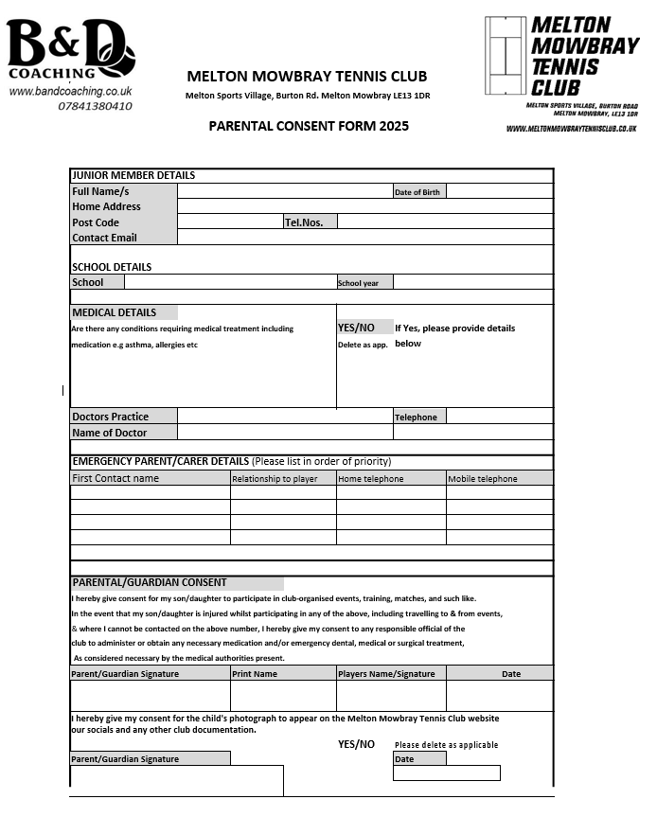
PARENTAL CONSENT FORM
PARENTAL CONSENT FORM 2026

