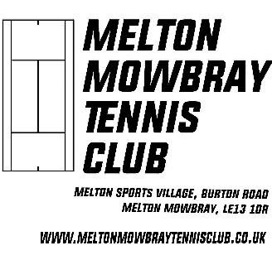

MELTON MOWBRAY TENNIS CLUB

Melton Sports Village, Burton Rd. Melton Mowbray LE13 1DR

PARENTAL CONSENT FORM

JUNIOR MEMBER DETAILS


 | Full Name/s |  |  |  |  | Date of Birth
 | Home Address
 | Post Code |  |  | Tel.Nos.
 | Contact Email
 | SCHOOL DETAILS
 | School |  |  |  | School year
 | MEDICAL DETAILS
 | Are there any conditions requiring medical treatment including |  |  |  | YES/NO | If Yes, please provide details
 | medication e.g asthma, allergies etc |  |  |  | Delete as app. | below

 | Doctors Practice |  | Telephone
 | Name of Doctor

EMERGENCY PARENT/CARER DETAILS (Please list in order of priority)

 | First Contact name | Relationship to player | Home telephone | Mobile telephone

PARENTAL/GUARDIAN CONSENT

I hereby give consent for my son/daughter to participate in club‐organised events, training, matches, and such like.

In the event that my son/daughter is injured whilst participating in any of the above, including travelling to & from events,

- where I cannot be contacted on the above number, I hereby give my consent to any responsible official of the club to administer or obtain any necessary medication and/or emergency dental, medical or surgical treatment,
as considered necessary by the medical authorities present.

 | Parent/Guardian Signature | Print Name |  | Players Name/Signature |  |  | Date
 | I hereby give my consent for the child's photograph to appear on the Melton Mowbray Tennis Club website our socials and any other club documentation.
 |  |  |  | YES/NO | Please delete as applicable
 | Parent/Guardian Signature |  |  |  | Date

